

Smart Masjid

Project Requirements

Prepared by
Mudassir Ahmed

Project Overview
The goal of the smart IoT speaker is to connect organizations that stream audio to their subscribers. Below are the steps identified in the workflow of the project.
- The organization would register with us, and we will provide them with Audio Encoder and Smart IoT button.
- The organization admin would then setup stream schedules using our web application.
- The subscribers would purchase speakers from us and connect their speaker via our mobile app and subscribe to organization of their choice.
- Once they have subscribed to the organization, they can subscribe to various streams offered by the organization.
- The organization will trigger an event from the smart IoT button provided by us when they want to start streaming.
- The speaker will receive the event and start streaming the audio from the media server.

Architecture
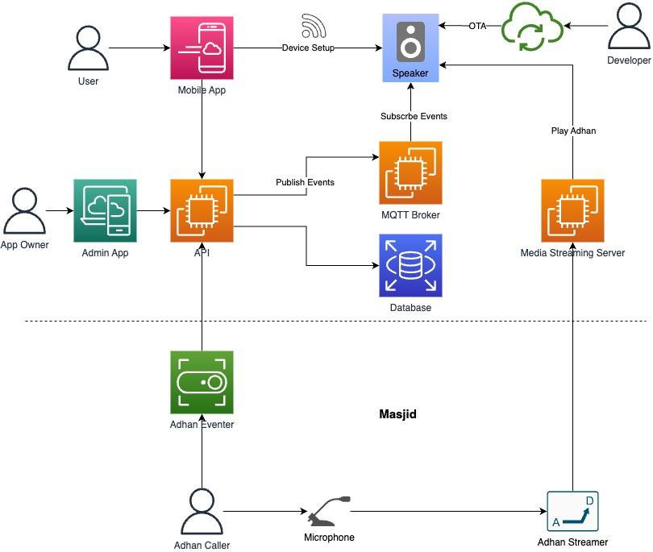

Components
Given below is the breakdown of the requirements based on the various components involved in this IoT speaker project.

MQTT Broker
- A secure MQTT broker setup to publish and subscribe events which in our case is AWS IoT Core. Out of scope for development.

IoT Speaker (Adhan Speaker)

Hardware Requirements:
  - ESP32 microcontroller
  - 3w speaker
  - Battery powered with USB type C port.
  - LED light (Ring or RGB)
    - Yellow blinking when not connected to WiFi
    - Green when connected to WiFi
    - Red when low battery
    - Green blinking when streaming
  - Power button
    - Turn on/off speaker
  - Volume up button
  - Volume down button
  - Mute button
    - Turn off audio streaming if pressed when audio is being played.
  - Reset device
    - Volume up + Volume down + Mute for 5 seconds

Firmware Requirements:
  - Ability to consume MQTT events
  - Play audio at good quality from streaming url
  - Device discoverability module via Wifi Access Point or BLE
    - Discover Device
    - Pass Wifi credentials
    - API endpoint to get device info (mac address and model)
  - Ability to make HTTP API calls
  - Ability to connect to WiFi
  - Animation for RGB LED ring
  - Ability to deploy firmware updates over the air (OTA) via APIs on the device
  - Send Telemetry
    - Connection Status
    - Battery life

Functional Requirements

Refer Process flows

Cost Requirements
  - BOM optimization to ensure that speaker is manufactured at best possible price in the market.

Miscellaneous Requirements
  - Size between 3.5 to 6 inches
  - Logo print

Mobile App
- Android app backwards compatible to Android version 6.0 (Marshmallow)
- iOS app backwards compatible to iOS version 10
- Refer Figma wireframes and Process flows for requirements.

IoT Button (Adhan Eventer)

Hardware Requirements
- ESP 32 microcontroller
- WiFi enabled button with LED
- Battery powered with DC power jack.

Firmware Requirements
  - Device discoverability module via Wifi Access Point or BLE
    - Discover Device
    - Pass Wifi credentials
    - API endpoint to get device info (mac address and model)
  - Ability to make HTTP API calls
  - Ability to connect to WiFi
- Button function
  - LED starts blinking or turns green when pressed first time
    - Calls API to start Adhan
  - LED stops blinking when pressed second time or if 5 minutes have passed after first press.
    - Calls API to stop Adhan
  - LED turns red when battery is below 50 %
- Animation for RGB LED ring
  - Ability to deploy firmware updates over the air (OTA) via APIs on the device
  - Send Telemetry
    - Connection Status
    - Battery life

Functional Requirements
- Refer Process flows

Cost Requirements
  - BOM optimization to ensure that speaker is manufactured at best possible price in the market.

Miscellaneous Requirements
- Not more than 5 inches
- Logo print
- Ability to screw on the wall

API:
- Backend for Mobile Application and Adhan Eventer. Out of Scope.

Admin App:
- Web Application to manage masjid, users and devices. Out of Scope.

Artifacts:

Process Flows:
Process Flow Diagrams

Mobile App Wireframes:
Figma Wireframes

